SMART DELIVERY OPERATIONS ANALYTICS SYSTEM
FINAL PROJECT REPORT
Submitted By: Goda Hari Krishna
Technology Stack: SQL | MySQL | Power BI

ABSTRACT
The Smart Delivery Operations Analytics System is a business intelligence solution developed to analyze food delivery operations. The project integrates customer, order, restaurant, delivery, payment and rating data to generate actionable insights. SQL was used for data cleaning, transformation and analytical querying, while Power BI was used to build interactive dashboards.

INTRODUCTION
Food delivery businesses generate large volumes of transactional data every day. Organizations require analytical systems that transform raw data into meaningful business insights. This project helps stakeholders understand customer behavior, revenue trends, restaurant performance and delivery efficiency.

PROBLEM STATEMENT
Delivery platforms often face challenges such as customer churn, delayed deliveries, inconsistent service quality and inefficient operational decisions. Without analytics, identifying these issues becomes difficult.

OBJECTIVES
1. Analyze revenue performance.
2. Monitor customer churn.
3. Evaluate restaurant performance.
4. Study payment trends.
5. Track delivery efficiency.
6. Create an interactive Power BI dashboard.

DATASET DESCRIPTION
The project uses Customers, Customer Behavior, Orders, Restaurants, Delivery Partners, Payments and Ratings datasets. Together they represent the complete delivery ecosystem.

Dataset Summary
Dataset | Purpose | Relationship
Customers | Customer master information | 1:M Orders
Customer Behavior | Spending & churn metrics | 1:1 Customer
Orders | Order transactions | Fact Table
Restaurants | Restaurant information | 1:M Orders
Payments | Payment details | 1:1 Orders
Ratings | Customer feedback | 1:1 Orders
Delivery Partners | Delivery operations | 1:M Orders

DATABASE DESIGN & ER DIAGRAM
The database follows a relational structure where Orders act as the central transaction table.
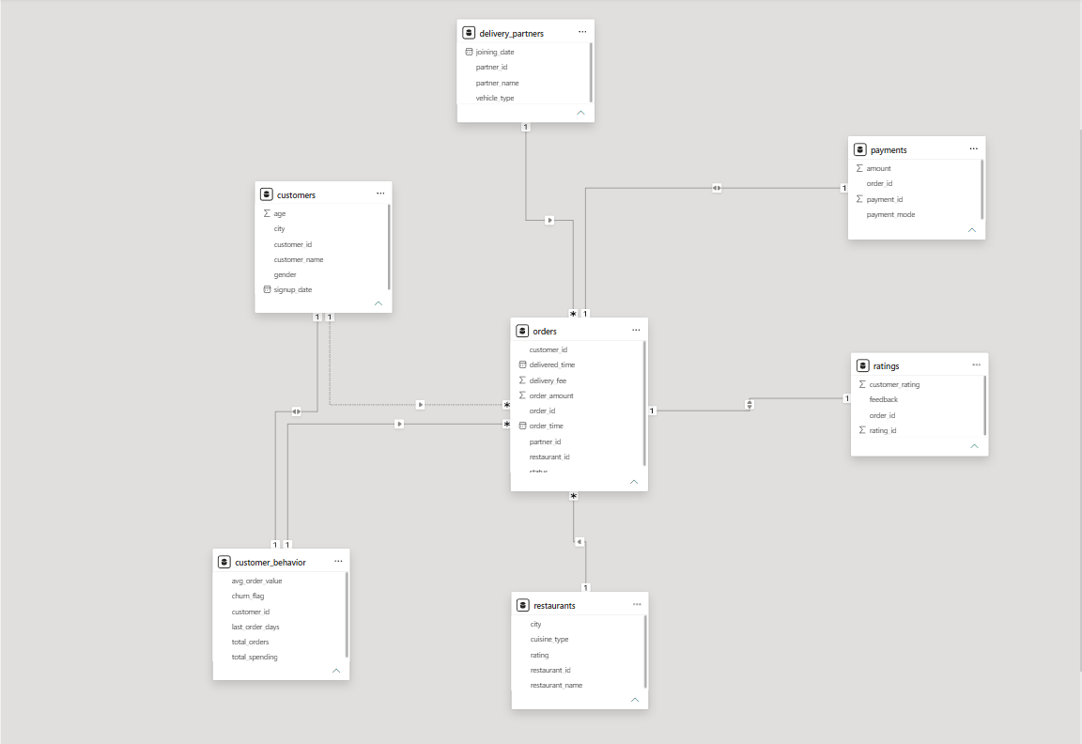

Relationship Explanation
Customers → Orders (1:M)
Restaurants → Orders (1:M)
Delivery Partners → Orders (1:M)
Orders → Payments (1:1)
Orders → Ratings (1:1)
Customers → Customer Behavior (1:1)

DATA CLEANING & TRANSFORMATION
Data quality is critical for analytics. The following steps were performed:
• Null value identification and handling
• Duplicate record checks
• Date format standardization
• Referential integrity validation
• Primary and foreign key verification
• Feature engineering for churn and spending metrics

SQL ANALYSIS
Analytical SQL queries were written to answer business questions:
• Total Revenue Analysis
• Delivery Delay Analysis
• Customer Churn Analysis
• Restaurant Performance Analysis
• Payment Mode Analysis
• Ratings Analysis
• City-wise Revenue Analysis

Sample Business Queries
1. Which city generates the highest revenue?
2. Which restaurants contribute the most revenue?
3. What is the average delivery time by city?
4. What percentage of customers have churned?
5. Which payment mode is most preferred?

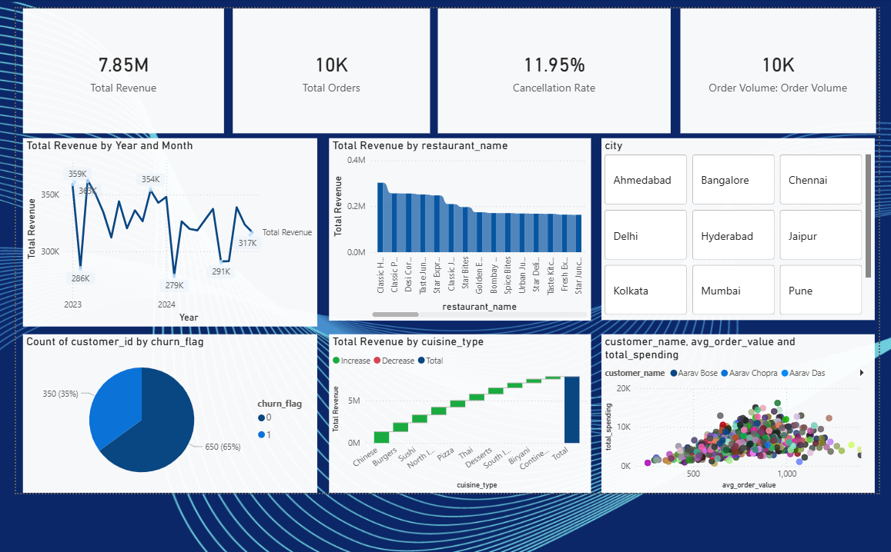
POWER BI DASHBOARD

The dashboard contains KPI cards, revenue trends, cuisine analysis, customer churn analysis, customer spending distribution and restaurant performance metrics.

Key Performance Indicators
Metric | Value
Total Revenue | 7846794.91
Total Orders | 10000
Cancellation Rate | 11.95%
Customer Churn | 35%

BUSINESS INSIGHTS
• Revenue remained stable across the reporting period.
• Chinese cuisine generated the highest revenue contribution.
• Digital payment methods dominate transactions.
• Top restaurants account for a significant portion of total revenue.
• Customer churn presents a major business opportunity.
• Higher order frequency is positively associated with customer spending.

RECOMMENDATIONS
• Launch loyalty programs for customer retention.
• Optimize delivery partner allocation.
• Promote high-performing restaurants and cuisines.
• Reduce cancellations through operational monitoring.
• Use predictive analytics for churn forecasting.
• Improve customer experience using ratings feedback.

FUTURE SCOPE
Future enhancements include machine learning-based churn prediction, demand forecasting, real-time dashboard integration, recommendation systems and route optimization.

CONCLUSION
The Smart Delivery Operations Analytics System successfully transforms raw operational data into actionable business insights. SQL enabled robust data analysis while Power BI delivered intuitive visualizations for decision-making. The project demonstrates the practical application of analytics in improving revenue, customer retention and operational efficiency.

